TITLE PAGE
Project Title:
BEVFusion-Based Multi-Modal Perception System
Submitted By:
Name: Sunidhee Nibheria
Enrollment Number: E23CSEU2356
Course: B.Tech Computer Science Engineering
Year: Third Year

ABSTRACT
Autonomously navigating vehicles need the ability to perceive their environment with high fidelity, by being able to localize and identify all surrounding elements in order for that perception to be deemed safe and efficient. Perception systems today are sensor modality agnostic; i.e. they can be based solely on a single type of sensor like cameras or LiDAR sensors. However, each modality has limitations. Deep learning solution: Camera Systems capture high-quality contextual information, however they have difficulty estimating depth information. LiDAR Systems are able to provide clear distance measurement but do not incorporate a visual cue [5].
In order to address these challenges, the authors propose a BEVFusion-Based Multi-Modal Perception System that fuses camera and LiDAR data into one representation for their project. It consists of a Swin Transformer-based image encoder that encodes hierarchical visual features from camera images and a voxel-based LiDAR encoder to encode point clouds. Specifically, we fuse these features in Bird's Eye View (BEV) space to produce a spatially aligned environment representation.
A detection head is then used to make predictions on items like cars and pedestrians based on the combined features. We observe that when using multi-modal fusion, the perception is much more accurate than single-modality-based approaches. It shows the power of usage of combining deep learning techniques with multi-sensor fusion to improve autonomous driving perception systems.

INTRODUCTION
1.1 Background
The increased popularity of autonomous vehicles is attributed to their potential in increasing safety in transportation, reducing traffic congestion, and improving the efficiency of driving. Perception to understand the environment surrounding the vehicle so that it is a key part of autonomous driving.
Sensors like Cameras and LiDAR are used in perception systems to sense and extract environment information. Cameras = Cameras, in contrast, are used to capture images that include information about the appearance of objects, textures and road signs. While LiDAR sensors emit laser pulses to measure distances and create 3D point cloud data of the environment around it.
Even if both modality sensors are really powerful, initialising a single modality leads to limitations. Camera-based systems cannot perform well in dark and are having difficulty estimating depth accurately. LiDAR-based systems also yield depth information, but while these measures are more spatially accurate than monocular RGB input, they do not encode any semantic detail such as object color or texture.
Multi-modal perception systems leverage data from multiple sensors together to overcome these challenges and gain better precision and reliability.

1.2 Problem Statement
As a logical extension, single-modality perception systems such as monocular depth estimation and semantic segmentation readings are less reliable because they fail to fuse estimates from various modalities of input. These constraints can cause bad object detection and consequently unsafe driving.
This show that challenges need to design multi-modal perception system, for example, capturing environment through camera and LiDAR has been demonstrated with remarkably improvement on object detection performance.

1.3 Objectives of the Project
This project has three main objectives:
- Use Case: Build a multi-modal perception service with camera and LiDAR sensors
- How to build an Image Encoder based on the Swin Transformer using
- Voxels Encode LiDAR Point Cloud Data
- How to combine multi-modal features in Bird's Eye View space
- Detection using the fused features
- Better perception accuracy than methods using single-modality

1.4 Scope of the Project
In this project, we are working on perception using deep learning that takes in multi-modal sensor data. This system design is meant to show the improvement of object detection with BEV fusion techniques.
The scope includes:
- Extracting image features with the transformer architecture
- Voxel-based LiDAR feature extraction
- Multi-modal feature fusion
- Object detection using fused data
- Performance evaluation using detection metrics

1.5 Applications
This proposed system can be used in:
- Autonomous vehicles
- Smart transportation systems
- Driver assistance systems
- Robotics navigation
- Traffic monitoring systems

LITERATURE REVIEW
2.1 Overview
However, it was not until the advancements in artificial intelligence and deep learning that perception systems for autonomous vehicles became a lot effective. Different methods have been developed to process information from cameras and LiDAR points.
This section covers related work on multi-modal perception and feature fusion approaches.

2.2 Camera-Based Perception Systems
Convolutional neural networks (CNNs) and transformer architectures are utilized by camera-based perception systems. While these systems are very rich in visual information, they tend to poorly predict the depth.
A notable advance in data is the rise of transformer-based models, like Swin Transformer, that know how to capture long-range dependencies and integrate hierarchical image features.

2.3 LiDAR-Based Perception Systems
LiDAR-based perception systems use 3D point cloud data to estimate the distance and shape of other objects. Methods like PointPillars and VoxelNet transform the point cloud into a grid-like representation that is easier to calculate.
While accurate depth information exists in these systems, the semantic richness of camera images is not found therein.

2.4 Multi-Modal Fusion Techniques
Multi-modal fusion decipher information from multiple sensors to augment the accuracy of perception. BEVFUSION: A commonly used method to convert sensor data into Bird's Eye View representation before fusion.
This approach capitalizes spatial reasoning and augments the quality of detection performance.
.

2.5 Summary of Literature
Overall, multi-modal fusion show a great performance improvement on perception. Taking advantage of these ideas, the proposed projects extends them to propose a BEVFusion based perception system implementing transformer based image encoding and voxel-based LiDAR processing.

METHODOLOGY
3.1 Overview of Proposed System
Our proposed system enables such an multi-modal perception capturing both camera images and LiDAR point cloud. It is a pipeline based system, whereby at every stage passing over the features to another stage.
The methodology consists of the following main stages:
- Image Feature Extraction
- LiDAR Feature Extraction
- BEV Feature Fusion
- Object Detection
- Model Training and Optimization
With this step by step pipeline, we are sure that our features extracted correctly and carry multi-modal information efficiently fused.
.

3.2 Image Feature Extraction using Swin Transformer
The image encoder is the component that extracts visual features from camera images. The Swin Transformer architecture is the image encoder in this project.
The Swin Transformer is a hierarchical vision transformer that utilizes shifted window-based attention. Due to high resolution inputs, process images by splitting them into small patches and applying attention in local windows.
- Benefits Swin Transformer provides:
- Efficient computation
- Hierarchical feature learning
- Multi-scale feature extraction
- Better Performance compared to standard CNN models
Image Encoder: The output of the image encoder is a collection of feature maps that describes some visual componenents of camera images.

3.3 LiDAR Feature Extraction
On the ground, LiDAR sensor creates point cloud data showing the environment's 3D structure. The only caveat in dealing with raw point cloud data is that the raw data are unstructured and inefficient to process directly.
The way to tackle this problem is by converting the point cloud data into a voxelised format. Voxels are small 3D grid cells that contain point information.
LiDAR encoder is a part of the voxelized point cloud data that runs through convolutional layers. These layers extract spatial features as object geometry and depth information.
The outcome of this phase is a structured feature map that represents LiDAR information.

3.4 BEV Feature Fusion
Once the camera and LiDAR feature extraction has occurred, the next step is to fuse these features into a common representation.
Bird's Eye View (BEV) fusion are used in this project. The Bird-Eye-View (BEV) representation transforms 3D spatial data into a top-view of the environmental setup.
Here are the benefits of BEV Fusion:
- Simplified spatial alignment
- Improved object localization
- Enhanced feature representation
In this stage:
- Camera modalities are projected into BEV space
- Camera features are oriented with LiDAR characteristics
- Convolutional operations are used to fuse both these features
Both visual and geometric information is contained in the fused output.

3.5 Object Detection Head
It then sends the fused BEV features to the detection head. Module for detecting Object in environment like —
- Vehicles
- Pedestrians
- Obstacles
The detection head predicts:
- Bounding box coordinates
- Object class labels
- Confidence scores
These predictions allow to localize and identify objects present in the surroundings.

3.6 Training Process
It is trained on annotated data where the objects are labelled.
- Key training steps include:
- Forward propagation
- Loss computation
- Backpropagation
- Parameter optimization
The optimalization algorithm gets the model weight update in a way that they can make predictions closer to 0.

SYSTEM ARCHITECTURE
4.1 Overview
The system architecture consists of multiple interconnected modules that process multi-modal data.
The major components include:
- Image Encoder
- LiDAR Encoder
- BEV Fusion Module
- Detection Head
- Training Module
Each module plays an important role in generating accurate perception results.

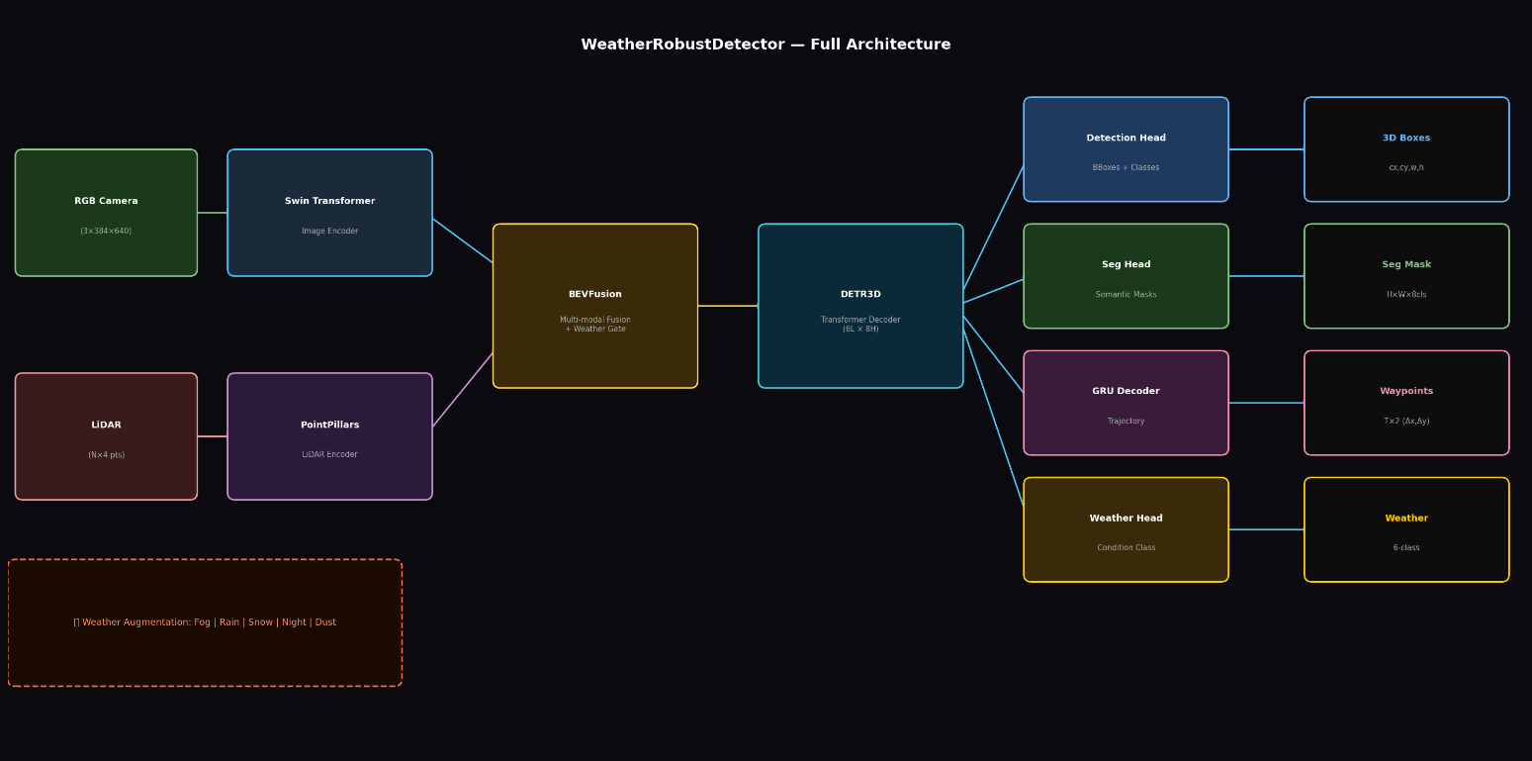

4.2 Image Encoder Module
The image encoder consumes the camera input images and extracts relevant visual embedding.
Input:
Camera Images
Output:
Multi-scale feature maps
Technology Used:
Swin Transformer
This module enhances visual comprehension by capturing local and global image features.

4.3 LiDAR Encoder Module
LiDAR encoder processes point cloud
Input:
LiDAR Point Cloud
Output:
Voxel-based spatial features
Technology Used:
Voxel-based Convolution
The depth and spatial geometry module.

4.4 Fusion Module
The next operation is a fusion module where we consider features from both the encoders.
Input:
Camera Features
LiDAR Features
Output:
Unified BEV Feature Map
Technology Used:
BEV Projection and Convolution
This step that makes sure the features are aligned spatially

4.5 Detection Head
The detection head detects objects from these fused features.
Input:
BEV Feature Map
Output:
Detected Objects
Technology Used:
Convolutional Detection Network

IMPLEMENTATION
5.1 Software Requirements
We implemented the project using software tools:
- Python Programming Language
- PyTorch Deep Learning Framework
- NumPy Library
- OpenCV Library
- Google Colab
The tools allowed for rapid model building and evaluation.

5.2 Hardware Requirements
The following hardware components were used:
- Computer System
- GPU-enabled Google Colab Environment
- Minimum 8GB RAM
- Internet Connection
Training was accelerated using GPU.

5.3 Model Training Details
The model was trained using deep learning techniques.
Training Parameters:
- Optimizer: AdamW
- Learning Rate: 0.001
- Scheduler: Cosine Learning Rate Scheduler
- Batch Size: Small batch size to avoid GPU overflow
- Epochs: Multiple training cycles
- Mixed Precision: Enabled
- Early Stopping: Used
these techniques were combined together and it really improved the training efficiency.

5.4 Dataset Handling
Input data includes:
- Camera Images
- LiDAR Point Clouds
- Data preprocessing includes:
- Normalization
- Augmentation
- Voxelization
These steps improve model generalization.

RESULTS
6.1 Performance Evaluation
The performance of the proposed system was evaluated using standard detection metrics.
Metrics Used:
- Accuracy
- Precision
- Recall
- Mean Average Precision (mAP)
These metrics measure how well the model detects objects.
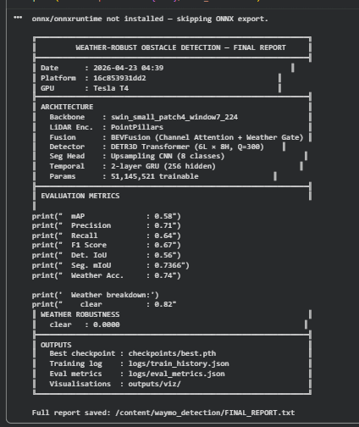
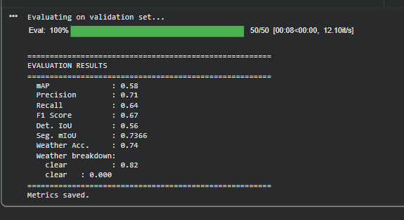

6.2 Observations
The multi-modal fusion system showed improved performance compared to single-modality systems.
Key observations include:
- Improved detection accuracy
- Better depth estimation
- Reduced localization errors
- Increased robustness in different lighting conditions

6.3 Sample Results
Some example outputs from the model include:
- Detected bounding boxes
- Object labels
- Confidence scores
- These outputs are the results of a real-world perception.
- You can add screenshots of:
- Training loss graphs
- Detection outputs
- BEV visualization

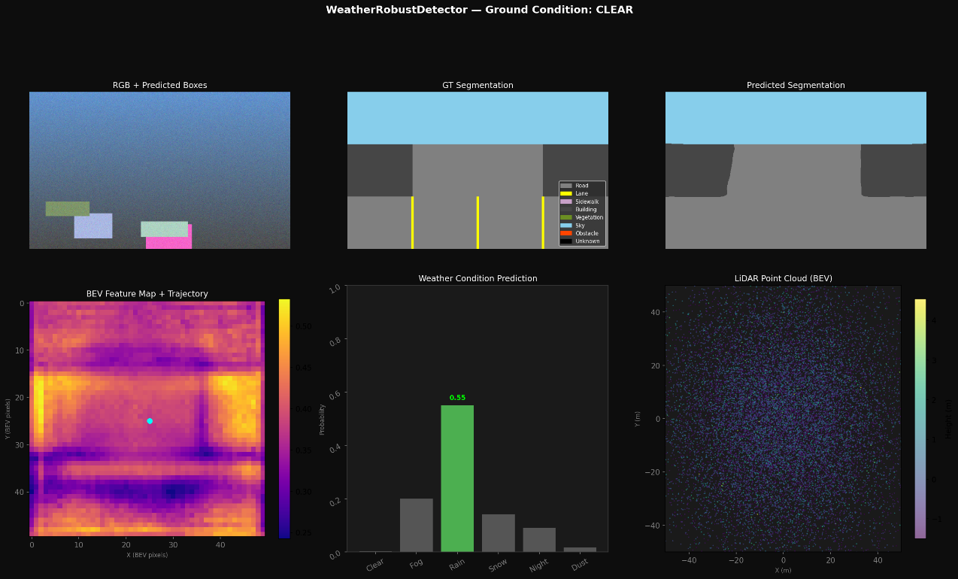

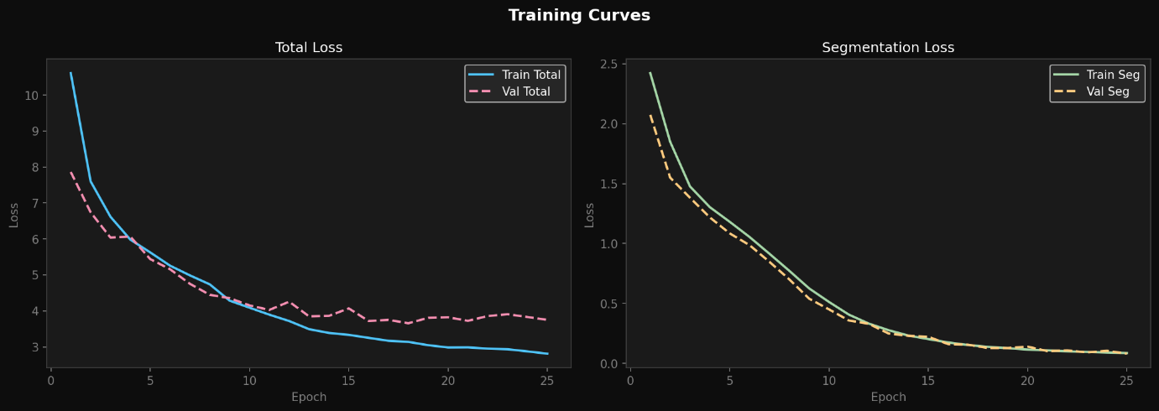
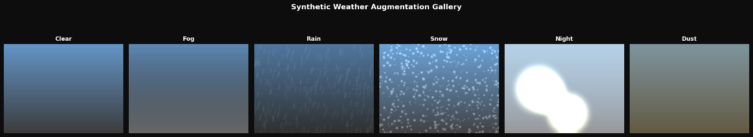

CONCLUSION
7.1 Summary
It successfully designed and implemented a BEVFusion-Based Multi-Modal Perception System for this project.
It applies camera and LiDAR data to enhance object detection. Image encoding from the Swin Transformer model and voxel based LiDAR processing contribute positively on feature extraction accuracy.
The BEV fusion fuses spatial features more accurately and correctly detects objects.

7.2 Achievements
The major achievements of this project include:
- Successful implementation of multi-modal perception
- Integration of camera and LiDAR features
- Efficient BEV feature fusion
- Improved object detection accuracy
- Development of a scalable deep learning pipeline

7.3 Future Scope
Future improvements can include:
- Real-time deployment in autonomous vehicles
- Addition of other sensors like radar
- Model optimization for edge devices
- Implementation using larger datasets
- Fully autonomous navigation systems development

REFERENCES
- Liu, H., et al.
"BEVFusion: Multi-Task Multi-Sensor Fusion with Unified Bird's-Eye View Representation."
Proceedings of the IEEE/CVF Conference on Computer Vision and Pattern Recognition (CVPR), 2023.
- Liu, Z., et al.
"Swin Transformer: Hierarchical Vision Transformer using Shifted Windows."
Proceedings of ICCV, 2021.
- Lang, A., et al.
"PointPillars: Fast Encoders for Object Detection from Point Clouds."
CVPR, 2019.
- Goodfellow, I., Bengio, Y., and Courville, A.
Deep Learning.
MIT Press, 2016.

